**Homework - 5**

*This homework can be solved by hand (pencil and paper). You should submit your solution to the “homework box” in front of the Machinery Lab. Late submissions will not be accepted!*

**Q.1. (20 pts)** Consider the single-phase 120 V, 2-pole, 50 Hz induction motor given in Figure 1. The stator winding is distributed in a number of slots in order to produce an approximately sinusoidal MMF distribution over space, centered on the winding axis.

1. Show that the expression of the MMF produced by stator is as following:

$$F_{1}=\frac{1}{2}\hat{F_{1}}\cos\left(θ-ωt\right)+\frac{1}{2}\hat{F_{1}}\cos\left(θ+ωt\right)$$

where $\hat{F_{1}}$ is the peak value of stator MMF corresponding to maximum instantaneous current.

1. Calculate the frequencies of induced rotor voltages in Hz due to forward and backward rotating MMF waves if the rotor is rotating at 2940 rpm in the forward direction at steady state. Comment on the results.

**HINT: $\cos\left(a±b\right)=cos⁡(a)cos⁡(b)∓sin⁡(a)sin⁡(b)$**

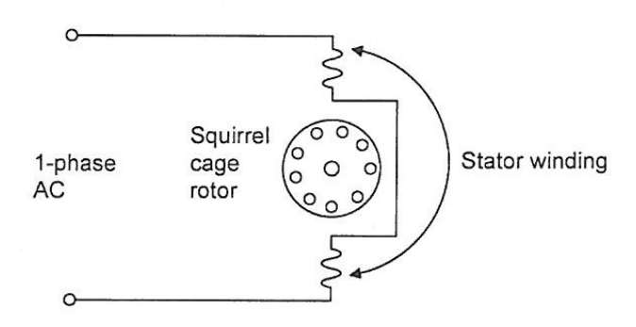

Figure 1: The single-phase induction motor

**Q.2. (40 pts)** A 3.3 kV, 50 Hz, 4-pole, Y-connected, 3-phase synchronous generator has a synchronous reactance of Xs = 4.2 Ω. It delivers power to an **infinite bus** via a power transformer and a feeder as shown in Figure 2. The transformer leakage reactance and the feeder reactance (referred to the armature side of the synchronous generator) are Xtr’ = 0.3 Ω/phase-wye and Xf’ = 0.1 Ω/phase-wye, respectively. All resistances can be neglected. Suppose that the power delivered to the infinite bus is **2.4 MVA at unity power factor**.

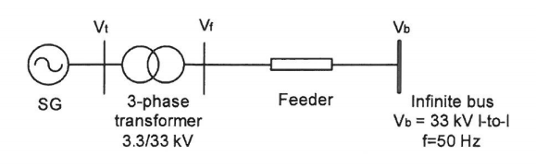

Figure 2: Single-line diagram of a grid-connected synchronous generator

1. Draw a phasor diagram of the overall system. Take the infinite bus voltage vector, referred to the generator side, Vb’ as the reference phasor.
2. Calculate the transformer’s secondary voltage referred to the generator side, Vf’, armature terminal voltage, Vt, and the excitation emf, Ef.
3. Calculate the load angle of the synchronous generator, δg and the load angle of the overall system, δs.
4. Compute the reactive power delivered by the synchronous generator.

**Q.3. (40 pts)** A 3-phase, 50 MVA, 10.5 kV l-to-l, 50 Hz, 10-pole synchronous machine is operating as a generator in a hydroelectric plant connected to a 10.5 kV, 50 Hz infinite bus. The field excitation of the generator is adjusted such that the generator is delivering **rated power to the infinite bus** **at unity power factor**. The parameters of the salient-pole machine are: Xd = 2.2 Ω/phase-wye and Xq = 1.6 Ω/phase-wye. All electrical and mechanical losses can be neglected.

1. Calculate the excitation emf, Ef and load angle, δ.
2. Compute the mechanical power, Pm delivered and the torque, Tm applied by the water turbine to the shaft of the generator.
3. Suppose now that a failure occurred in the field exciter such that the field current became zero. Can the generator continue to deliver its rated power? Prove your proposition!